Translation „Reparaturverfahren in der Kanalnetzinstandhaltung BI Umweltbau 5/2012“

**Maintenance of the Sewer Grid: Repair Methods**

**A report on experiences made in the Ruhr Valley, Germany**

Authors: Dipl.-Ing. (FH), M. Eng. Volker Hülshorst, Stadtwerke Essen AG

Dipl.-Ing. Frank Großklags, Stadt Bochum

1. **Introduction**  
   Sewer services are an important part of public services, which underlie the inter-generational contract. Comprehensive technical and legal norms govern the tasks of planning, building and operating the mostly underground waste water infrastructure.   
     
   In principle any installation for the collection and the transport of wastewater must not allow the exfiltration of sewage nor the infiltration of groundwater, i.e. they must be leak-proof. The also must be reliable to operate. The waste water must at any time be transported within the parameters of the original sizing. In addition these installations must always be maintained to a sound condition, which excludes any endangerment of the public or a disruption of the above surface infrastructure or traffic.  
     
   The realization of these requirements in the day to day praxis pose a significant challenges to the owners and operators of a sewer system, which are addressed with diverse strategies. Based on the examples of the cities of Essen and Bochum this paper will discuss the constraints of strategic action and the tools for the realization.  
     
   Financing the operation of a sewer system and the associated and required construction measures are independent from the organizational form of the owning entity and results from the mandated users’ fees. The guidelines for the cost allocation are part of the State Law for Communal Fees and Charges (KAG) and are thus the same for all sewer system owners.  
     
   The budget for rehabilitation (renewal, renovation, repair) of a sewer system is limited due to the financing ways. Decisions are made on the basis of economical considerations evaluating depreciation and repair cost. The directive for the evolution of fees is in general to keep them steady or allow a constant moderate increase. The budget available for rehabilitation is a function of the existing fees and an accepted increase.  
     
   1. Sewer System Essen
      1. The Owner

On January 1st, 1998 City Works Essen (Stadtwerke Essen AG – SEG) took over the responsibility for planning, constructing and operating the sewer system, which had been owned by the City until this time. Simultaneously the grid itself was sold to Discharge Essen GmbH (Entwässerung Essen GmbH – EEG), a 100% daughter company of City Works AG. The actual responsibility for the proper discharge of waste water lies still with the City of Essen, as mandated by the Water Law of the State of North-Rhine-Westphalia.  
  
Planning, construction and operation of sewage treatment plants is performed by Ruhrverband and Emschergenossenschaft, two regional waste water associations.

The Essen City Works also supplies the area with natural gas and drinking water and additionally operates a center for logistics in Essen harbor.

* + 1. **Key Data**

The sewer grid owned by EEG has a total length of 1,60 km (1,000 miles) and is mainly operated as a combined rainwater/sewer system with gravity flow. There are only marginally few pressured systems. 54,000 sections average approximately 31 m (100 ft.) in length.

Distribution of systems

Rainwater 5%

Sewage 7%

Combined Systems 88%

**Illustration 1: Essen Sewer Grid Distribution of systems**

The sewer grid originated from partial grids, which had been individually planned for the separate parts of town, which were later merged into the municipality of Essen. Other significant elements for the development of the grid were mining and industry.

The different phases of this development can be identified in the depiction of the age structure of the grid.

**Illustration 2: Age distribution in the Essen sewer grid (1)**

The materials used are typical for the time phase in which the grid was constructed. It consists up to 90 % of fire clay and concrete.

Material distribution

Steinzeug = fire clay

GFK = grp

Kunststoff = plastic

Mauerwerk = brick

PEHD = PEHD

Sonstige = other

unbekannt = unknown

Beton = concrete

**Illustration 3: Material distribution in the Essen sewer grid (1)**

* 1. *Bochum Sewer Grid*

**1.1.3 The owner**

The grid is operated by the department of Civil Engineering of the City of Bochum, which also owns the grid.

Planning, construction and operation of the sewage treatment facilities is done by Ruhrverband and Emscher-Genossenschaft. In a few and exceptional cases the city does this work and then hands the facility over to the respective organization. To a large extent the city has taken on the responsibility for the maintenance and supervision of these plants from the organizations.

**1.1.4 Key data**

The grid extends over 1238 km (750 miles) of pipe. It has 135 special structures (pumping stations, overflow facilities, rain retention basins. There are an additional 50 km (30 miles) of public waters into which content from the grid can be discharged.



Regenwasser = rain water

Schmutzwasser = sewage

Mischwasser = combined system

**Illustration 4: system distribution in the Bochum grid**

The shapes are mainly circular, but there are also egg-, taper- and box-shapes.



DN 401 – 800 = 16” – 32” 25%

DN 801 – 1600 = 32” – 64” 9%

>DN 1600 = >64” 2%

<DN 300 = <12” 6%

DN 300 – 400 = 12” – 16” 58%

**Illustration 5: cross-section distribution in the Bochum grid**

The majority of the grid (about 70%) is made of concrete/reinforced concrete. The rest consists of brick, clay, plastic, asbestos cement and ductile iron.



Beton, StB = concrete, reinforced concrete 76%

Mauerwerk = brick 1%

Kunststoff = plastic 2%

Asbest = asbestos cement 1%

Guß, Stahl = ductile iron, steel 1%

Steinzeug = clay 19%

**Illustration 6: Material distribution in the Bochum grid (2)**

**2. Problem Statement**

It is impossible to exactly forecast the technical life of an individual portion of the grid, i.e. the moment, when the usable reserves are used up and damages occur. It is possible to use statistical methods and aging models in order to develop a scenario of wear specific for the grid which show the principal (probable) development of individual clusters of line sections. Yet one cannot make a specific prediction for an individual segment. Along with the disruption of the whole section one has to consider the possibility of localized damages, which can be repaired or rehabilitated. These events can be estimated for individual clusters with the application of the models described above.

Whether a decision taken in practice for the renewal, rehabilitation or repair will lead to the calculated development of the grid, can only be judged in the future. This means also that the distribution of the total budget onto renewal, , renovation or repair based on such a prognosis model does not necessarily lead to the desired results. The practical decision to repair, rehabilitate or renew still remains the “great art” of the planner. The relevant factors for maintenance and modernization are age structure and the budget for an of the sewer grid in question. These factors can be influenced only in a limited way, yet sensible solutions must be found to live up to the intergenerational contract.

The age structure of the Essen grid (shown as a decades cluster) exemplifies one of the principal problems of many sewer grids. In spite of the flattening through clustering we find a non-homogenous age structure. Non-homogenous is defined as the proportion of the length of a grid from one decade to the overall grid length. With a homogenous structure and an expected life of 100 years one would find nearly 10% of the total grid in each decade. At an expected technical life of 80 years this value ought to be about 12.5% of the grid length. This poses two problems, which are discussed below:

1. Taking an average technical life of 80 years one finds about 20% of the pipes, which have already exceeded this age. This value will grow to about 20% in the next two decades, if there are no renewals in these clusters. Even if we take an average renewal rate of 1.25% per year there still remains a deficit of about 5% at the end of the decade.
2. The decades “until 1970” and “until 1980” comprise at present a portion of also about 30% of the grid length. Viewed in isolation and at a renewal rate of 1.25% per year we’ll have a negative balance of approximately 5%.

In praxis one has to add the factors cross-section and depth, which exclude a continuous renewal rate at a steady budget. It is also not possible to put the complete renewal budget into one decade. So it is inevitable to have a certain number of sections, which are beyond their technically useful life.

This requires the grid owner to look at the factors budget, age structure and the really existing substance value of each individual segment ant their consequences for the grid in its totality and to optimize them. The owner will have to design an individual strategy in order to satisfy the individual constraints.

**Illustration 7: Age cluster of the Essen sewer grid (1)**

1. **Rehabilitation strategies**
   1. **Essen:**

The design of a holistic rehabilitation concept is based upon DIN EN 752 “Drainage Systems outside of Buildings” in conjunction with regulation DWA – A 118. The emphasis lies in the areas of hydraulic and structural examinations. The need for investigating aspects of environmental relevance and further reviews is determined by the specifics of the grid. Planning is done per area, the sequence is a result of the legal requirements and the cycle of the execution of the structural evaluation according to the “Self-regulatory Regulation for Sewers (SüwV Kan).

As part of the development of a holistic rehabilitation concept one analyzes the structural and hydraulic potential and deficits. This analysis supplies the data basis for a long-term repair plan. The roadmap to the desired grid is made up within the framework of the plans and describes the concrete renewal, rehabilitation and repair measures for a period of 15 years, i.e. until the next structural as-is examination.

These measures of the individual and area oriented rehabilitation concepts are fed into the list for the continuation of the Waste Water Disposal Concept (ABK) and made part of the concrete scheduling of realization.

**3.2. Bochum**

Like in Essen when crating a holistic rehabilitation concept the focus is on the inspection of the structural and hydraulic conditions. In contrast to Essen, though, planning and rehabilitation in Bochum is done for the complete city.

First data from a data bank containing information from inspections according to SüwV Kan classifying damages and hydraulics is analyzed.

After the automated classification still sections of damage class 0.1 and 2 are re-examined and reclassified manually.

Side factors like hydraulics, changing from combined systems to separate systems and/or the actual visual of a damage determine the rehabilitation method.

If one looks at the evaluation of the classification of the damages, one can easily see that not all sections classified 0 and 1 need to be renewed in an open trench manner because of the financial means.



**Illustration 8: Damage classifications in the Bochum sewer grid (2)**

In addition to the measures resulting from inspections according to SüwV Kan there are repairs because of road construction and immediate action due to sinkholes or foreign water ingress.

1. **Technical Challenges**

The decision to renew or renovate is mostly based upon the results from the structural and hydraulic review together with the knowledge of process technologies typical for a particular season and the materials used.

On the other hand the decision to repair is the result of the search for existing values in substance implies in most cases the decision for a specific technology. Each individual case presents a catalogue of requirements, which must be fulfilled by the process applied.

These requirements can be generalized based upon the conditions – typically the kind of damage, age classification, materials – so that finally some typical and reoccurring problems remain.

The City of Bochum is facing – like many other communities in the region – the results of underground coal mining. Mining was done over 300 years (the last coal mine in Bochum closed in 1973), but the unregulated mining close to the surface leads to many instances of surface subsidence of quite a few meters.

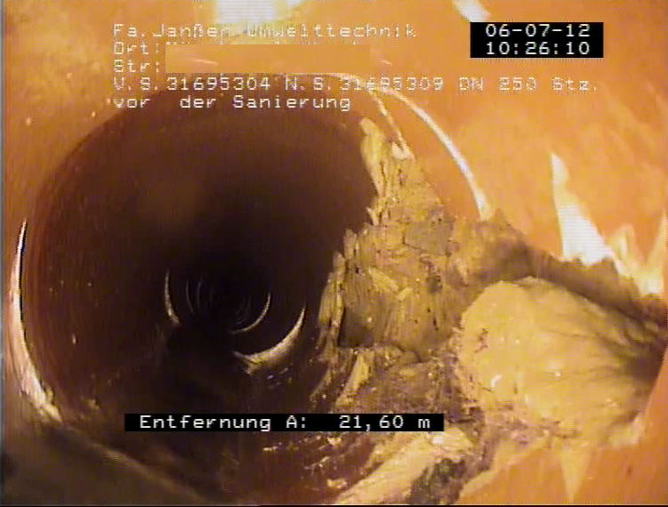

**Illustration 9: Shards**

Another major factor in for the condition of the sewer lines is the method used by many owners in the 60s, whereby the lateral connections were not drilled but “hammered” into the main. The space between the lateral line and the much too large opening was “closed and sealed” with bricks, bags of cement, or whatever else was available. Very often this resulted in cracks and shards especially with sewer lines made of clay.

The distribution of damages in the following graph shows the described problems and their dimension. Off-sets, cracks and shards and damaged laterals make up 79.5 % of the total damages.

Of course not every off-set can be connected to mining. Compaction when constructing the sewer line or other factors may have played a role. This also applies to damaged laterals or cracks and shards. Yet based upon video inspections a large proportion of these damages can be attributed to the causes mentioned above.



Stutzen/Anschluss = lateral / lateral connection

Verschiedene = miscellaneous

Lageabweichung = off-sets

Risse/Scherben = cracks/shards

**Illustration 10: Kinds of damages in the Bochum sewer grid**

The sewer grid in Essen shows in addition to the typical mining damages and the “hammered” lateral connections another wide spread problem: There are a number of “branched-off lines, which have not been covered properly. These covers (like rocks) move over time and often represent the only weak spot in an otherwise high substance value pipe section.

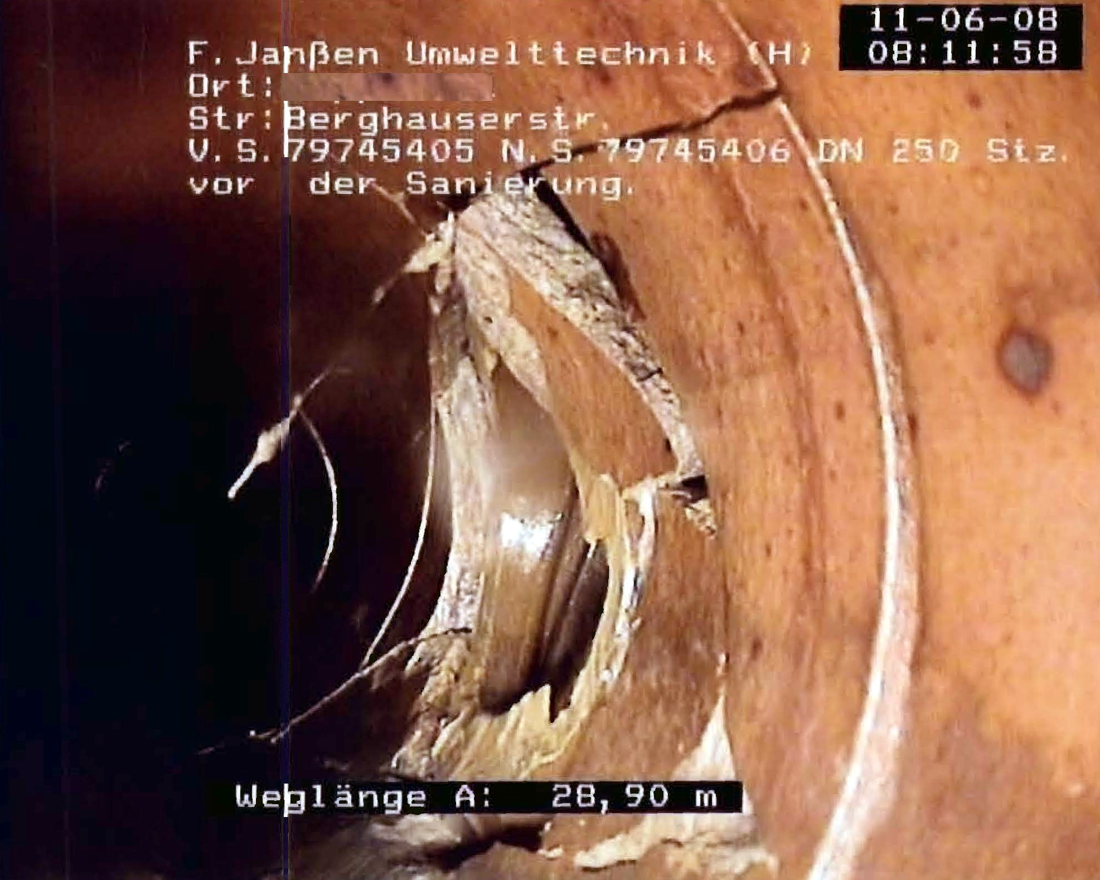

**Illustration 11: Damaged lateral connection**

**5 Technical Solutions**

The search for a technical solution is guided by the following considerations:

* The cause of a large number of damages , which have to be repaired in an open trench were in a disrupted pipe/soil system
* A structural calculation of repair technologies is only possible after conducting respective reviews because of the lack of knowledge of the existing pipe/soil system
* Such reviews in order to gain the necessary data can render any repair method commercially non-viable.

The potential technologies should therefore be capable of improving the pipe/soil system and offer a high guarantee for tightness because of their technical procedure and process. In addition a wide range of application ought to be possible.

In the way to retain the substance value and in view of the desired tightness of the pipe-system – two points of the highest priority for the grid owner – injection processes (here “Janssen Process”) have been used in both grids.

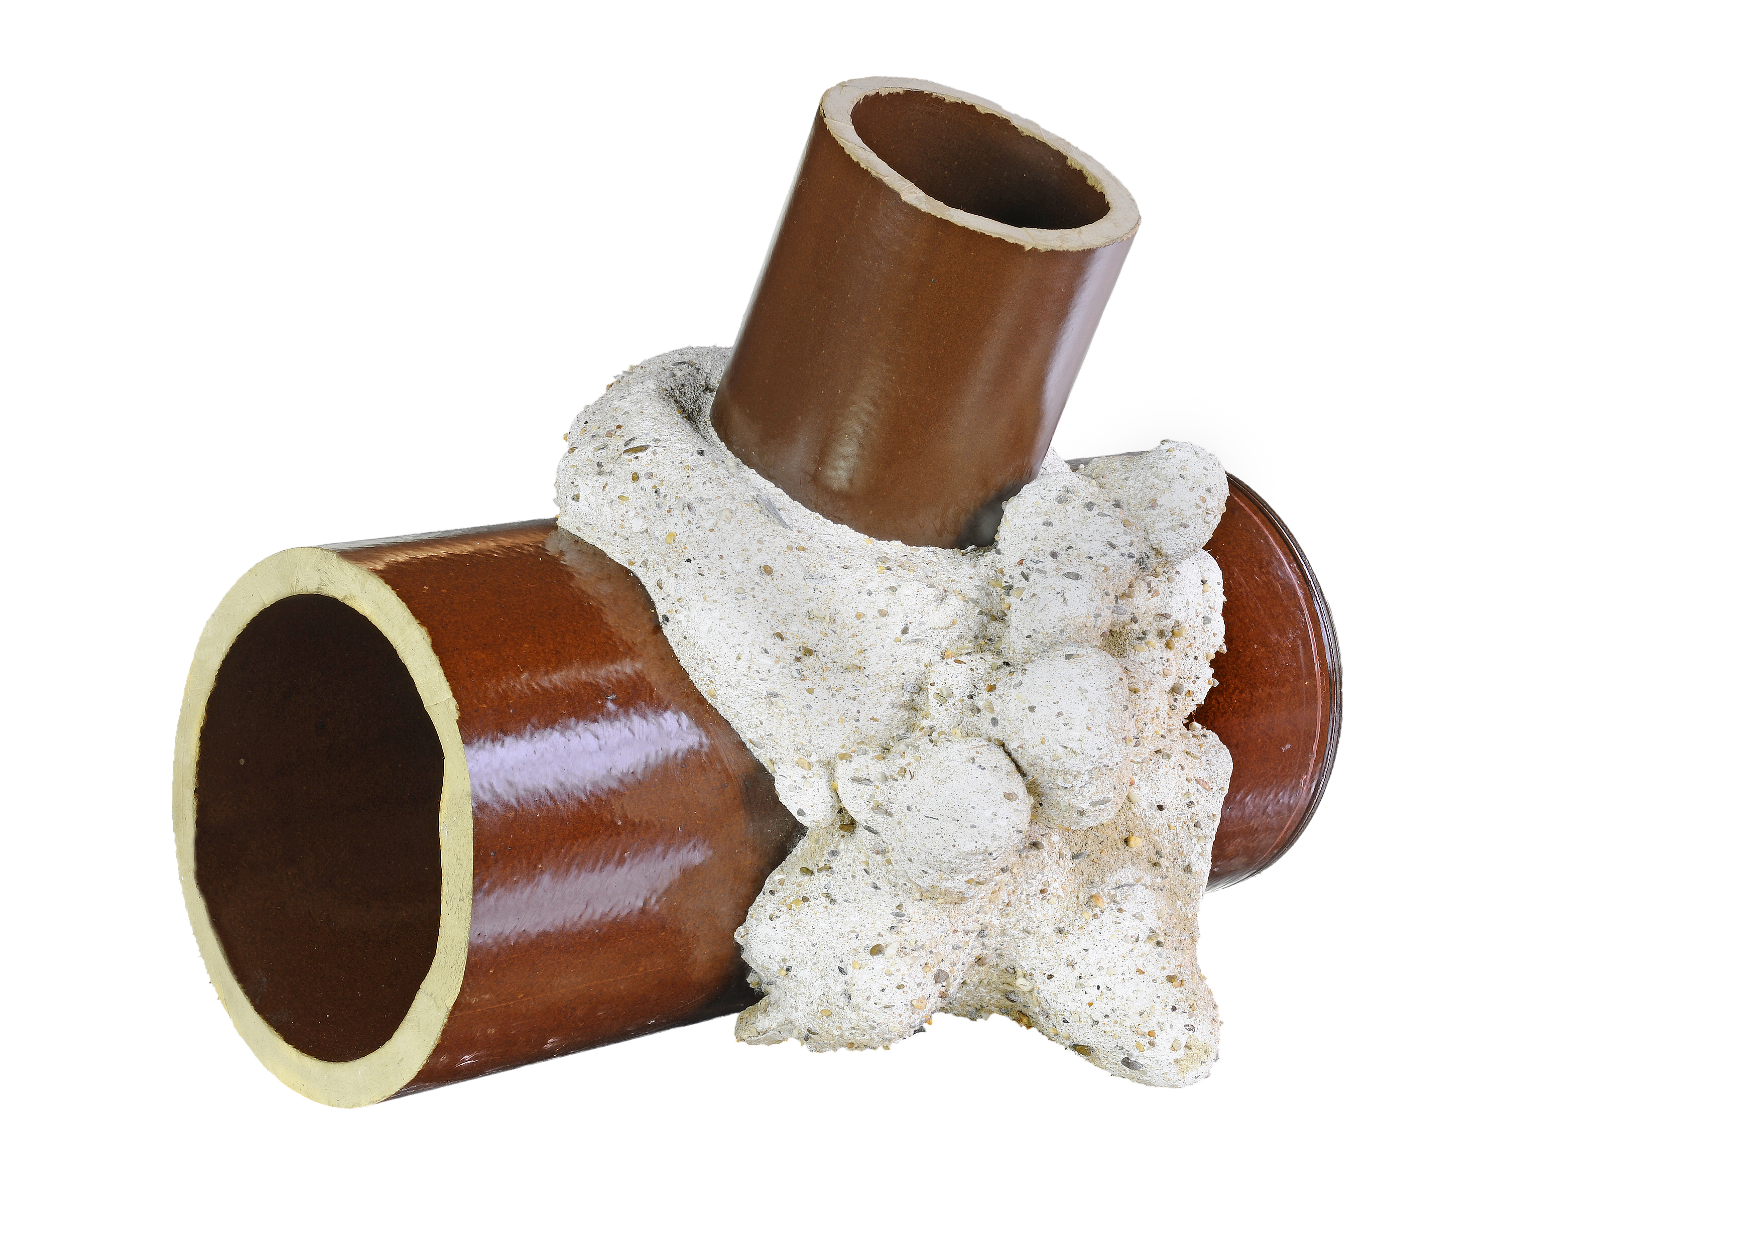

**Illustration 12: Dug-out lateral connection after injection**

Even without static and structural calculations and scientific evaluation we can state based upon experience, that the “Janssen Process” as a tool for the protection of the substance value has bee of great value for both grid owners.

Over more than 10 years Essen City Works have had excellent results with thousands of injections using the Janssen Process. The properties of the stabilized pipe/soil system and the sealing characteristics have proven their worth. It has been shown that the life expectancy of the repair is considerably longer because of the injection process, than could originally be expected on the basis of the evaluation standards. Even after 10 years the rehabilitation has shown to be successful, shown by TV inspection and the absence of expected sink holes.

In 2011 a total of approximately 10 km (6.2 miles) were rehabilitated in Bochum, with 60% being partial repairs.

For more than 15 years the City of Bochum has been using miscellaneous technologies for partial repairs, the Janssen injection process being one of them. There were many different types of damages which were repaired like shards, missing wall pieces, cracks, in- and ex-filtration.

Sink holes, where soil gets into the sewer and which cause holes in the street or a lateral connection with voids behind it – identified by cctv inspection, or cracks and leaking joints make a partial repair inevitable. The inspector decides which process to use on the basis of the actual damage. A sink hole caused by a leaking lateral or a void around a lateral connection requires the stabilization and sealing of the soil/pipe system. It is important to fill and seal the void and the lateral connection as quickly and effectively as possible and to rebuild the road surface, so that traffic can flow again. Our practical experience shows that structural safety and integrity has always been provided.

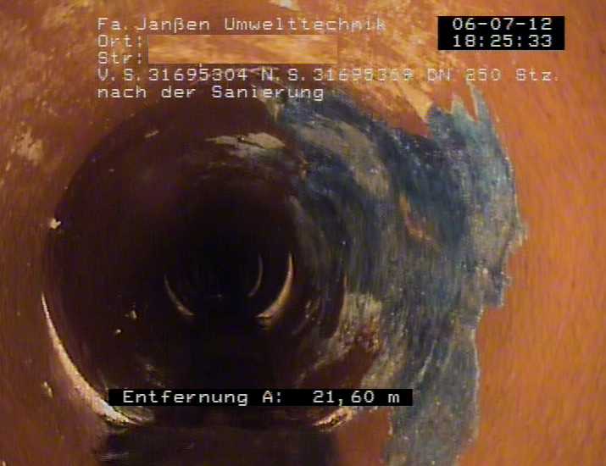

**Illustration 13: Post Point Repair**

When finding a singular damage classified as 0 or 1 in a section, which is otherwise intact, a partial repair is most of the time sufficient. Here too the choice of the rehabilitation process is determined by the appearance of the actual damage and its surroundings as well. In case of suspected visible voids Bochum decides to inject.

The range of applications is very wide. In some individual cases other methods are used as well. Yet the limitations of the Janssen Process compared to other technologies are very small. In our experience similar results in sealing and stabilizing the soil/pipe system cannot be achieved with any other technology.

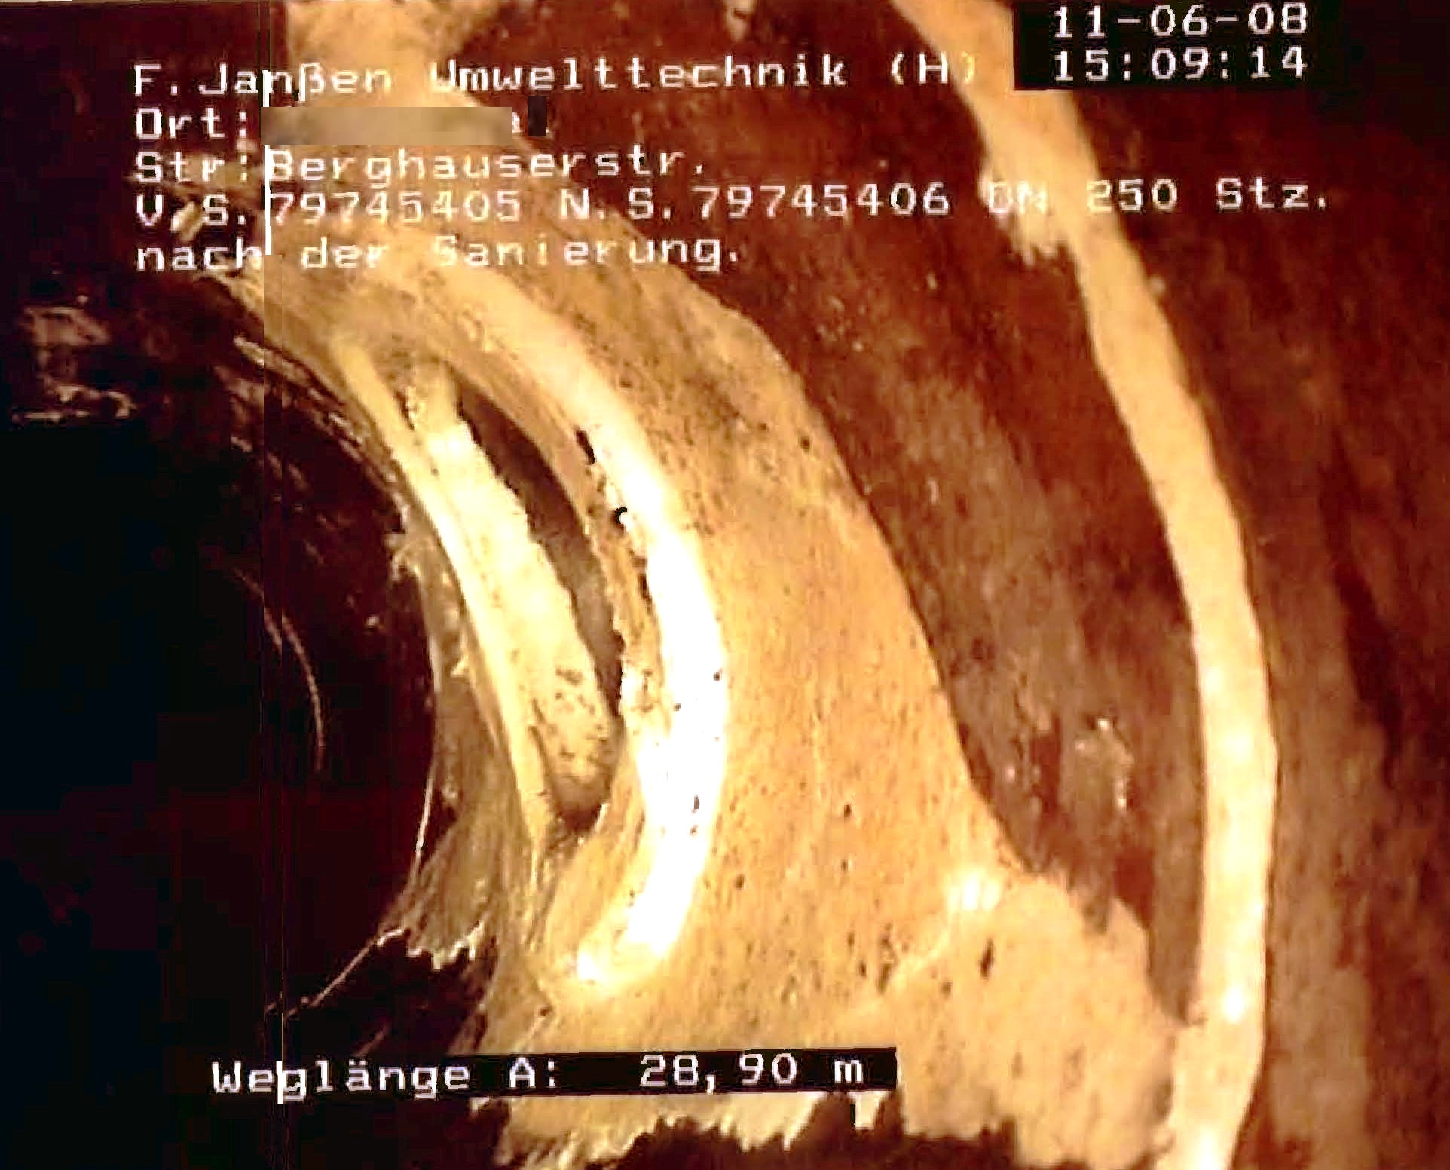

**Illustration 14: Post Repair Lateral Connection**

**6 Summary**

The Janssen Injection Process has become for both grid owners a very important component for the realization of the rehabilitation strategies due to its very good technical life expectancy, the practically unlimited range of application and the excellent performance in conjunction the wide range of experience gained over the past 10 – 15 years.

Partial repairs are indispensable. Which method to use is a result of the actual damage and lies in the responsibility of the decider. Experience along with judgment based upon technical know-how are the basis of such decisions.

There is only operating experience and individual case results for repair technologies on top of DIBT certification, IKT and material testing by test labs. Generally valid scientific conclusions on the repair technologies available in the market today gained in-situ do not exist. The practical use in the grids of Essen and Bochum over the past 10 respectively 15 years allow the statement that there has been a long-term proof of the viability of the Janssen Injection Process, which could be wished for for many other technologies.

Sources:

1 City Works Essen

2 City of Bochum, Department of Civil Works

3. Umwelttechnik Franz Janßen GmbH